Proforma for submission of idea of Incubatee

1. Details of Incubatee:

1.1* Details of the Host Institute (HI)

1.2 * Name of the Business Incubator (BI)

1.3* Category of the Incubatee- MSME/ Student/ Others

|  |  |  |
| --- | --- | --- |
| Entrepreneurs/MSME | Student | Others |

1. Aadhaar Number/ Virtual Id

|  |  |
| --- | --- |
| Aadhaar Number | Virtual Id |

* Enter Aadhaar Number/ Virtual Id

* Name In Aadhaar

1.4*Incubatee Name

1.5 *State                                                                            

1.6* District                                                

1.7 *Email Id

1.8*Mobile Number

1.9*Category          

1.10*Gender

|  |  |  |
| --- | --- | --- |
| Male | Female | OTHERS |

1.11*Address

2. Details of Idea:

2.1* Title of proposed idea/innovation

2.2* Whether the idea involves use of existing intellectual property or not, give brief detail there of  
Maximum 1500 characters allowed.

2.3*Briefly explain newness/uniqueness of the innovation  
Maximum 1500 characters allowed.

2.4*Concept & Objective  
Maximum 1500 characters allowed.

2.5*Specify the potential areas of application in industry/market in brief  
Maximum 1500 characters allowed.

2.6*Briefly provide the market data for the potential idea/ innovation  
Maximum 1500 characters allowed.

2.7*Name and details of Mentors  
Maximum 500 characters allowed.

2.8*Experience and Qualification of Mentors

2.9*Contact Details of Mentors

2.10* Current Development Status of innovation  
Maximum 500 characters allowed.

2.11*Expected time of completion of idea  
Maximum 500 characters allowed.

2.12*Idea Theme                                

2.13*Idea Sector

|  |  |  |  |  |
| --- | --- | --- | --- | --- |
| Agriculture, Rivers & Ocean Produce based industries, fertilizers, Agricultural Implements & Agro processing and any related sub-sector | Healthcare & Life sciences, Medical Devices, Pharmaceuticals, Biotech, AYUSH and any related sub-sector | Power, Renewables, Electricals, Power Electronics, Energy Efficiency and any related sub-sector | Services, Education, Hospitality, Media, Publishing, Entertainment, Design, Wellness, Logistics, Sports and any related sub-sector | Miscellaneous Sector (Environment, Forests, Water & Sanitation; Foods, Beverages, FMCG, Consumer Goods; Infrastructure, Construction, Housing; IT, ITES, Electronics, White Goods, Telecommunication; Metals, Engineering, Machinery, Automation and Transportation, Automotive, E Vehicles, Railways, Aviation, UAV and any other sub-sector) |
|  |  |  |  |  |

3.Financial requirements:

3.1*Please give activity-wise break-up as mentioned below

|  |  |  |  |
| --- | --- | --- | --- |
| **Particular/Item** | **Total idea project cost (Rs. In lakh)** | **Amount GOI assistance (Rs. In lakh)** | **Incubatee share (Rs. In lakh)** |
| Technology related Expenditure towards machine usage charges etc., Electricity charges, Procurement of raw material , testing/Calibration charges, other charges essential for development of idea **Max (10.00) lakh.** |  |  |  |
| Charges for mentor/handholding supporting team **Max (3.00) lakh.** |  |  |  |
| Travelling Expenses or any other item not coverd as above may be allowed as per need for development of the idea **Max ( 2.00) lakh.** |  |  |  |

*Total idea/project cost (Rs in lakh):

*Total GOI Assistance required (Rs in lakh):

*Total Incubatee share (Rs in lakh):

4.Please give name of other students/Entrepreneurs associated with this project/idea, if any (in the periodical order):

|  |  |  |
| --- | --- | --- |
| **Name** | **Aadhar No/Udhyog Aadhar No//Udyam Registration** |  |
|  |  |  |
| Note:- Please fill above information and click Add button.You can repeat adding for multiple students/Entrepreneurs associated with this project/idea. | | |

Note:- Kindly do not write the Name/Organization Name/ Company Name of the incubatee in order to maintain transparency in the evaluation process. (If found, the idea will not be considered.)

* Ref. No.

* 5. Summary of the idea. This is the section reviewers read to understand the technical solution. Please state the solution clearly. Reviewers may ask: What is the actual technical advancement or improvement provided by this solution?  
Maximum 750 characters allowed.

* 6 (a) Is it a new concept?

|  |  |
| --- | --- |
| Yes | No |

* (b) Prior art on the concept, if any  
Maximum 300 characters allowed.

* 7. Main Problem Being Addressed in the Project (Every solution targets a certain problem. Please use this section to highlight the specific problem the solution addresses. This section can be as short or as long as needed to describe the precise problem the solution addresses)  
Maximum 500 characters allowed.

8. Background for getting the idea?

* a. Who is it for?  
Maximum 300 characters allowed.

* b. What will it do?  
Maximum 300 characters allowed.

* c. Any unique features? Explain?  
Maximum 300 characters allowed.

* 9. How simple or complex will the idea’s execution or implementation be? What are the risk factors involved in executing the idea?  
Maximum 500 characters allowed.

* 10. How soon could the idea be put into operation? (TRL of prototype)  
Maximum 200 characters allowed.

* 11. How much investment would you need for prototyping of the Idea?  
Maximum 200 characters allowed.

* 12. (a) How do you intend to protect your idea (i.e. your intellectual property or IP)? Status of IPR (If any)  
Maximum 300 characters allowed.

* (b) Related Background. This section is used to highlight information that can be used by the reviewers or patent attorney to help put the solution in proper context. You can think of this section as something similar to the introduction section of an academic publication. This section is specifically reserved for other people’s work (please include competitive work) as well as your past work that you believe will aid the reviewers in understanding the technical landscape. Data related to or supporting your solution should not be in this section, it should be in Section III: “How is this Solution Made and Used.”  
Maximum 500 characters allowed.

* 13. How is this project made and used: Please describe in as much detail as possible how the innovation is implemented? This includes details on how you actually make, assemble, synthesize, or build the solution and details on how the solution is used once it is made. Reviewers will ask: How does the technical innovation actually work – or – what is the detailed process to achieve the technical innovation? Please help convince the reviewers with supporting statements using as much of the following that is available: your thoughts, logic, supporting literature, and/or experiments.  
Maximum 500 characters allowed.

* **Upload Detailed Proposal with Financial Breakup:**

**Cost Benefit:**

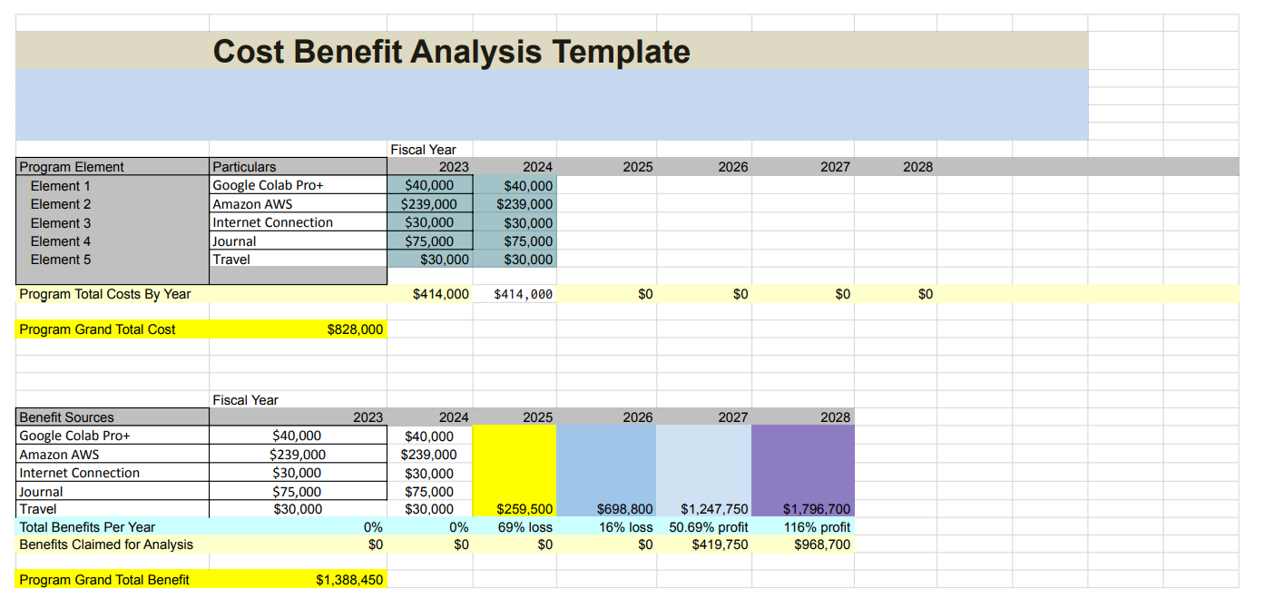

Dataset preparation:

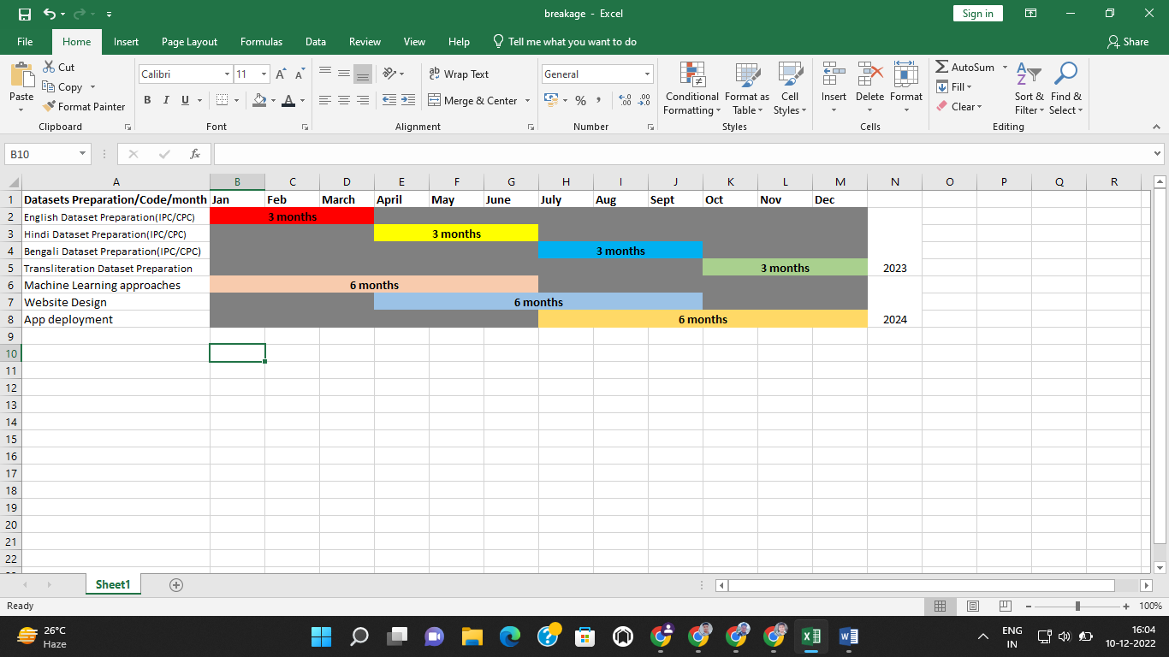  
  
Budget Calculation:

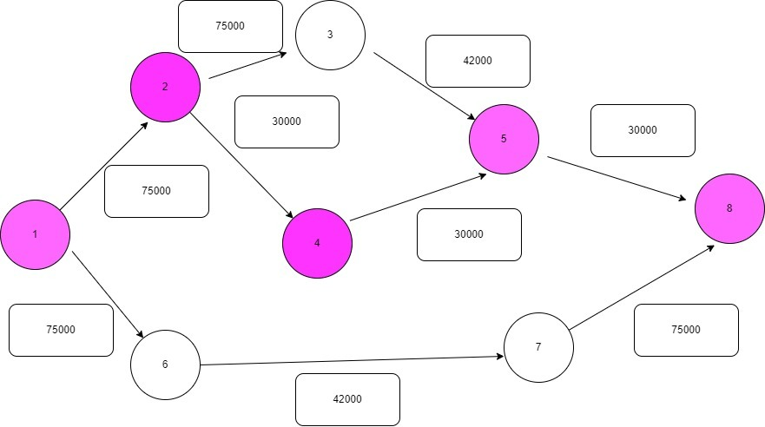

1 denote as a January to March

2 - April to June

3 - July to September

5 - Oct to December

8 – Execution

Prototype:

Prototype GIF is attached with this.